SANJIVANI UNIVERSITY
School of Engineering and Technology
Department of Artificial Intelligence & Data Science

UNIT-1 MINI PROJECT REPORT
Enterprise Student Record and Academic Management Platform
Design Thinking and Product Planning

Submitted by
BARHATE SANKET MARUTI
PRN: 2126UDSM2527

Class: DSY 2nd Year - AI & DS
Place: Kopargaon

Under the Guidance of
Karan Gaikwad Sir (IBM)

Head of Department: K. P. Jadhav Sir
Dean: Kavitha Rani P.

Academic Year: 2026-2027

CERTIFICATE

This is to certify that Mr. Barhate Sanket Maruti, PRN 2126UDSM2527, student of DSY 2nd Year, Department of Artificial Intelligence & Data Science, Sanjivani University, Kopargaon, has successfully completed the Unit-1 Mini Project titled "Enterprise Student Record and Academic Management Platform - Design Thinking and Product Planning" under the guidance of Karan Gaikwad Sir (IBM).
The work presented in this report follows the Unit-1 mini-project activities and deliverables prescribed for business understanding, design thinking, IBM Design Thinking, stakeholder analysis, user personas, requirements engineering, product vision, MVP definition, roadmap, project planning, and initial system architecture.

Role | Name | Signature
Project Guide | Karan Gaikwad Sir (IBM) | ________________
Head of Department | K. P. Jadhav Sir | ________________
Dean | Kavitha Rani P. | ________________

Date: ____________ Place: Kopargaon

DECLARATION
I, Barhate Sanket Maruti, PRN 2126UDSM2527, student of DSY 2nd Year - Artificial Intelligence & Data Science at Sanjivani University, Kopargaon, hereby declare that this Unit-1 Mini Project Report titled "Enterprise Student Record and Academic Management Platform - Design Thinking and Product Planning" has been prepared by me for academic submission.
The report documents the product-planning work expected in Unit-1. The project begins with understanding the academic-management domain rather than directly starting implementation. It identifies users and stakeholders, studies their needs and pain points, defines functional and non-functional requirements, applies Design Thinking and IBM Design Thinking, defines an MVP, prepares a product roadmap, and proposes an initial system architecture.
I have used the supplied Unit-1 mini-project guide and training/project reference document as the basis for the structure and terminology of this report.

Name: Barhate Sanket Maruti
PRN: 2126UDSM2527
Signature: ____________________

ACKNOWLEDGEMENT
I would like to express my sincere gratitude to Sanjivani University, School of Engineering and Technology, Department of Artificial Intelligence & Data Science, for providing the academic environment and opportunity to undertake this Unit-1 mini project.
I am thankful to my project guide, Karan Gaikwad Sir (IBM), for providing guidance and direction regarding Design Thinking, product planning, requirements engineering, stakeholder identification, and the overall software product development lifecycle.
I also express my gratitude to K. P. Jadhav Sir, Head of Department, and Dean Kavitha Rani P. for their academic support and encouragement.
Finally, I thank my teachers, classmates, and everyone who contributed directly or indirectly to the understanding and planning of this project.
Barhate Sanket Maruti

ABSTRACT
The Enterprise Student Record and Academic Management Platform is a proposed software product for managing student records and academic information within a higher education institution. The project is developed as a Unit-1 mini project with emphasis on product discovery, business understanding, Design Thinking, IBM Design Thinking, stakeholder analysis, requirements engineering, MVP planning, and product roadmap creation.
The central idea is to reduce the difficulties associated with fragmented or manual academic record management. The proposed platform brings student registration, academic records, attendance, examination information, results, and report generation into a structured digital system. The project deliberately focuses on understanding the problem and planning the product before implementation.
The report follows the five Design Thinking stages: Empathize, Define, Ideate, Prototype, and Test. It also documents IBM Design Thinking principles of Focus on User Outcomes, Restless Reinvention, and Diverse Empowered Teams, along with the Observe -> Reflect -> Make loop.
The final planning output includes a Business Requirements Document, product vision, stakeholder matrix, personas, functional and non-functional requirements, MVP scope, roadmap, initial architecture, project charter, repository structure, and product-discovery documentation.
Keywords: Student Records, Academic Management, Design Thinking, IBM Design Thinking, Requirements Engineering, MVP, Product Roadmap, Software Engineering.

TABLE OF CONTENTS
No. | Section | Page
1 | Introduction and Project Overview | 7
2 | Business Understanding | 8
3 | Problem Identification and Business Requirements | 9
4 | Design Thinking - Empathize | 10
5 | Design Thinking - Define | 11
6 | Design Thinking - Ideate | 12
7 | Design Thinking - Prototype and Test | 13
8 | IBM Design Thinking | 14
9 | IBM Loop: Observe -> Reflect -> Make | 15
10 | Stakeholder Analysis | 16
11 | User Personas | 17
12 | Requirements Engineering - FRS | 18
13 | Requirements Engineering - NFRS | 19
14 | Product Vision and Business Objectives | 20
15 | Minimum Viable Product (MVP) | 21
16 | Product Roadmap | 22
17 | System Architecture and Repository Structure | 23
18 | Project Charter, Milestones and Conclusion | 24

1. INTRODUCTION AND PROJECT OVERVIEW

1.1 Background
Modern software products are expected to solve real user and organizational problems rather than simply demonstrate coding ability. The supplied training reference describes software product engineering as a complete lifecycle involving research, architecture, user experience, quality assurance, automated deployment, and monitoring.
The Unit-1 mini-project specifically requires students to understand the educational domain, identify stakeholders, analyze user needs, define requirements, prepare a product vision and roadmap, and create a project plan before moving to later development units.

1.2 Project Title
Enterprise Student Record and Academic Management Platform - Design Thinking and Product Planning

1.3 Project Objective
The objective is to design and plan a software platform that can organize student and academic information in a centralized manner. The project focuses on product discovery and planning, not on premature coding.

1.4 Project Scope
- Student registration and profile management.
- Academic record management.
- Attendance management.
- Examination and result management.
- Academic report generation.
- Role-based access for major academic stakeholders.
- Structured product requirements and roadmap for future implementation.

1.5 Expected Outcome
At the end of Unit-1, the project should provide a clear product definition that is ready for Agile planning and subsequent development. The prescribed deliverables include BRD, Product Vision, Stakeholder Analysis, Personas, FRS, NFRS, Design Thinking, IBM Design Thinking, IBM Loop, MVP, roadmap, architecture, project charter, repository structure, and product-discovery documentation.

2. BUSINESS UNDERSTANDING
Business understanding is the starting point of the proposed product. The Unit-1 guide asks students to study academic management processes such as admissions, course registration, attendance, examination, and result management, and to identify problems associated with manual record management.

2.1 Academic Management Process
Process | Purpose | Expected Platform Support
Student Admission | Create student identity and academic profile | Registration and profile records
Course Registration | Associate students with programs/courses | Course and enrollment records
Attendance | Track academic participation | Attendance entry and reports
Examination | Manage assessments and marks | Exam records and marks
Result Management | Generate academic outcomes | Result processing and reports
Report Generation | Provide academic summaries | Student and administrative reports

2.2 Manual Process Challenges
- Duplicate or inconsistent student information across records.
- Difficulty locating the latest academic information.
- Time-consuming preparation of attendance and result reports.
- Dependence on individual staff members for record updates.
- Limited centralized visibility for administrators.
- Greater possibility of human error during repeated data entry.

2.3 Proposed Business Response
The proposed platform creates a centralized digital record structure. It aims to provide controlled access, consistent records, searchable information, and report-generation capabilities. This is a planning-level proposal and will require validation with actual institutional workflows before production implementation.

3. PROBLEM IDENTIFICATION AND BUSINESS REQUIREMENTS

3.1 Problem Statement
Students, faculty members, academic administrators, examination-cell staff, and IT support personnel may interact with student information through different processes. When records are fragmented or handled manually, users can face delays, repeated data entry, difficulty finding information, and reporting effort. The project therefore proposes a centralized Student Record and Academic Management Platform.

3.2 Business Requirements Document (BRD)
BRD ID | Requirement | Business Need | Priority
BR-01 | Centralized student records | Single source of academic information | High
BR-02 | Attendance management | Track attendance efficiently | High
BR-03 | Examination records | Maintain assessment information | High
BR-04 | Result generation | Reduce manual result preparation | High
BR-05 | Academic reports | Support student and administrative reporting | High
BR-06 | Role-based access | Control access according to responsibilities | High
BR-07 | Search and retrieval | Find records quickly | Medium
BR-08 | Future scalability | Support expansion to additional modules | Medium

3.3 Business Objectives
- Digitize core student and academic records.
- Reduce repetitive manual record handling.
- Improve accessibility of authorized academic information.
- Provide consistent academic reporting.
- Create a scalable product foundation for later Agile development.

3.4 Success Criteria
Success will be assessed through measurable product outcomes such as completion of core workflows, accurate retrieval of records, usability feedback from intended users, correct role-based access, and successful generation of required academic reports.

4. DESIGN THINKING - EMPATHIZE
Design Thinking is described in the reference material as an iterative, human-centered problem-solving framework that prioritizes understanding users before evaluating technological constraints. Its first stage, Empathize, focuses on studying users and their pain points.
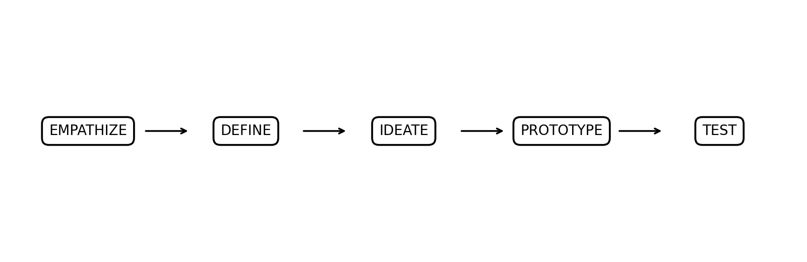
Figure: Five Stages of Design Thinking

4.1 User Groups
User Group | Typical Activities | Possible Pain Points
Students | Registration, attendance review, results | Waiting, unclear status, repeated requests
Faculty Members | Attendance and academic updates | Repeated entry, scattered information
Academic Administrators | Record supervision and reports | Manual consolidation
Examination Cell | Exam and result processing | High volume of records
IT Support | System support and access management | Multiple user and system issues

4.2 Empathy Questions
- What information does the user need most frequently?
- Where does the user currently spend unnecessary time?
- Which academic records are difficult to retrieve?
- What errors or misunderstandings commonly occur?
- Which tasks should be simplified without removing necessary controls?

4.3 Empathy Findings to Validate
At the planning stage, these findings are treated as hypotheses to be validated with actual students, faculty, administrative staff, and examination staff. The next stages convert validated observations into a focused problem definition.

5. DESIGN THINKING - DEFINE
The Define stage converts user observations into a focused problem statement. The reference guide describes this stage as formulating the problem after empathy-building and organizing collected data into a definitive core problem statement.

5.1 Core Problem Statement
"Students and academic staff need a reliable and centralized way to manage and access student academic information because fragmented or manual processes can create delays, repeated data entry, inconsistent records, and additional reporting effort."

5.2 Point-of-View Statements
- Student: I need quick access to my academic information so that I can understand my current academic status without depending on repeated manual requests.
- Faculty member: I need structured student and attendance records so that academic updates can be maintained efficiently.
- Administrator: I need centralized and accurate records so that I can prepare reports and monitor academic operations.
- Examination staff: I need reliable examination and result records so that result processing can be performed systematically.

5.3 How Might We Questions
- How might we centralize student academic records?
- How might we make attendance information easier to maintain and retrieve?
- How might we simplify result preparation and academic reporting?
- How might we provide each stakeholder only the information relevant to their role?
- How might we design the product so it can grow into additional academic modules?

6. DESIGN THINKING - IDEATE
The Ideate stage encourages broad solution exploration before technical optimization. The reference material lists brainstorming of useful capabilities as part of this stage.

6.1 Feature Brainstorm
Idea | User Value | MVP Status
Student profile module | Centralized student information | Include
Attendance module | Track and review attendance | Include
Examination module | Maintain exam information | Include
Result module | Generate academic outcomes | Include
Report generator | Create academic summaries | Include
Notifications | Inform users about important events | Future
Mobile application | Access from mobile devices | Future
Analytics dashboard | Visual academic insights | Future
AI recommendations | Personalized academic suggestions | Future

6.2 Solution Concept
The proposed solution is a role-based web platform with a centralized database and modular application design. Users authenticate into the system and access modules according to their roles. Student information, attendance, examination records, and results are maintained in structured entities. Reporting functions use the same centralized records to reduce repeated manual preparation.

6.3 Design Principles
- Keep core student workflows simple.
- Use clear navigation and understandable labels.
- Separate user responsibilities through role-based access.
- Design modules independently so future features can be added.
- Validate important workflows through prototypes before development.

7. DESIGN THINKING - PROTOTYPE AND TEST
The reference material recommends low-fidelity prototypes before expensive backend development. Its prototype examples include login, user search, operational dashboards, and administrative analytics. Testing is used to evaluate navigation, clarity, and task completion before frontend engineering.

7.1 Proposed Low-Fidelity Screens
Screen | Main Components | Purpose
Login | Username/PRN, password, role-aware access | Authenticate users
Student Dashboard | Profile, attendance, results, notices | Student self-service
Faculty Dashboard | Class list, attendance, academic updates | Faculty operations
Admin Dashboard | Student records, reports, management | Administration
Exam/Result Screen | Exam, subject, marks, result status | Academic result workflow
Report Screen | Filters, preview, export | Generate reports

7.2 Prototype Testing Tasks
- Find a student record.
- Open attendance information.
- Enter or review academic information.
- View examination and result records.
- Generate a basic academic report.
- Verify that a role cannot access an unrelated administrative function.

7.3 Test Feedback Template
Test Area | Observation | Action
Navigation | To be validated with users | Revise menu labels if required
Data clarity | To be validated | Improve field grouping
Task completion | To be measured | Remove unnecessary steps
Access control | To be verified | Adjust role permissions

8. IBM DESIGN THINKING
The Unit-1 guide requires application of the IBM Design Thinking principles Focus on User Outcomes, Restless Reinvention, and Diverse Empowered Teams. It also requires documentation of the Observe -> Reflect -> Make cycle.

8.1 Focus on User Outcomes
The project should define outcomes in terms of what users can accomplish, not only what technology is built. For example, instead of defining success as "create a student database," the product outcome can be "enable authorized users to find and update a student's academic record through a clear workflow."

8.2 Restless Reinvention
The platform should be treated as an evolving product. User feedback, workflow observations, testing results, and future institutional requirements should feed later iterations. A feature that is acceptable in the first version can be improved after real-world use.

8.3 Diverse Empowered Teams
The proposed product benefits from collaboration between academic stakeholders, product/design roles, developers, QA, database personnel, and IT operations. Different roles contribute different views of the same academic workflow.

8.4 Product Outcome Examples
Technical Activity | User Outcome
Create student record API | Authorized staff can maintain student records
Create attendance module | Faculty can update attendance systematically
Create report generator | Administrators can obtain academic reports efficiently
Add role-based access | Users see functions relevant to their responsibilities

9. IBM LOOP: OBSERVE -> REFLECT -> MAKE
The IBM Loop described in the reference follows a continuous cycle of Observe, Reflect, and Make. Observation studies user interactions, logs, and operational friction; reflection analyzes metrics and priorities; making converts insights into design, code, and automated delivery.
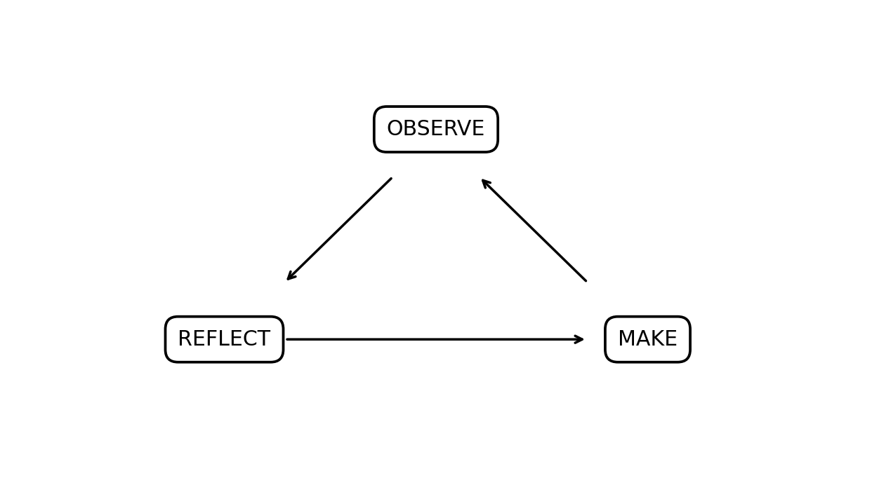
Figure: IBM Observe -> Reflect -> Make Loop

9.1 Observe
- Observe how students access their records.
- Observe how faculty maintain attendance.
- Observe administrative report preparation.
- Collect usability feedback and workflow issues.
- Review system usage information after implementation.

9.2 Reflect
- Identify repeated user difficulties.
- Compare expected and actual workflow completion.
- Prioritize improvements based on user impact.
- Review requirements when institutional needs change.

9.3 Make
- Improve the user interface.
- Refine validation and business rules.
- Add or modify modules based on validated needs.
- Test changes before release.
- Prepare improvements for future iterations.

9.4 Continuous Improvement Example
If students repeatedly struggle to locate result information, the team can observe the navigation path, reflect on the reason for the friction, and make a simplified results section. The same cycle can then be repeated after the change.

10. STAKEHOLDER ANALYSIS
The Unit-1 guide explicitly identifies students, faculty members, academic administrators, examination cell staff, and IT support personnel as important stakeholders.
Stakeholder | Role | Expectation | Influence
Students | Primary academic information users | Easy access to own records | High
Faculty | Academic data contributors | Efficient attendance and academic updates | High
Academic Administrators | Operational oversight | Accurate records and reports | High
Examination Cell | Exam/result operations | Reliable exam and result data | High
IT Support | Technical support | Maintainable and supportable system | Medium
Management | Institutional oversight | Visibility and compliance | High

10.1 Stakeholder Responsibility Matrix
Activity | Student | Faculty | Admin | Exam Cell | IT
Profile | View | View | Manage | View | Support
Attendance | View | Manage | Monitor | View | Support
Examination | View | Contribute | Monitor | Manage | Support
Results | View | Contribute | Monitor | Manage | Support
Reports | View own | Class | Generate | Generate | Support

11. USER PERSONAS
User personas represent important stakeholder types and help the team keep user needs visible during product planning. The Unit-1 guide requires personas to include goals, responsibilities, challenges, and expectations.

11.1 Persona 1 - Student
Attribute | Details
Name | Aarav Student
Goal | Access academic information quickly
Responsibilities | Review own profile, attendance and results
Challenges | Repeated requests, unclear status, delays
Expectation | Simple dashboard and accurate information

11.2 Persona 2 - Faculty Member
Attribute | Details
Name | Priya Faculty
Goal | Maintain academic and attendance information
Responsibilities | Update attendance and academic records
Challenges | Repeated data entry and record consolidation
Expectation | Efficient class-wise workflows

11.3 Persona 3 - Academic Administrator
Attribute | Details
Name | Dr. Anil Administrator
Goal | Monitor academic records and generate reports
Responsibilities | Manage records and reporting
Challenges | Manual consolidation and inconsistent information
Expectation | Centralized dashboard and reporting

12. REQUIREMENTS ENGINEERING - FUNCTIONAL REQUIREMENTS
The Unit-1 guide requires functional requirements for student registration, attendance management, result generation, and report generation.
ID | Functional Requirement | Description | Priority
FR-01 | User Authentication | Users shall authenticate before accessing protected modules. | High
FR-02 | Student Registration | Authorized staff shall create and update student records. | High
FR-03 | Student Search | Authorized users shall search student records using defined fields. | High
FR-04 | Attendance Management | Faculty shall record and review attendance. | High
FR-05 | Examination Management | Authorized staff shall maintain examination information. | High
FR-06 | Result Management | Authorized users shall enter and view result information. | High
FR-07 | Report Generation | Authorized users shall generate academic reports. | High
FR-08 | Role Management | Access shall depend on the user's assigned role. | High
FR-09 | Profile View | Students shall view their own academic profile. | Medium
FR-10 | Data Validation | The system shall validate required fields before saving. | High

12.1 Functional Workflow
Login -> Role Identification -> Dashboard -> Select Academic Module -> Validate Input -> Store/Retrieve Record -> Display Result -> Generate Report where applicable.

12.2 Functional Acceptance Examples
- A valid authorized user can log in and access the appropriate dashboard.
- Required student fields cannot be saved when incomplete.
- Attendance records are associated with the correct student/course context.
- Result information is displayed for the correct student.
- Users cannot directly access functions outside their assigned role.

13. REQUIREMENTS ENGINEERING - NON-FUNCTIONAL REQUIREMENTS
The project requires non-functional requirements including security, usability, reliability, and scalability.
ID | Category | Requirement
NFR-01 | Security | Authentication and role-based authorization shall protect academic data.
NFR-02 | Security | Sensitive credentials shall not be stored in plain text.
NFR-03 | Usability | Core workflows should use clear labels and consistent navigation.
NFR-04 | Reliability | The system should preserve data consistency during normal operations.
NFR-05 | Performance | Common record retrieval operations should respond within an acceptable time under expected load.
NFR-06 | Scalability | The architecture should permit addition of future academic modules.
NFR-07 | Maintainability | Modules should be separated clearly to simplify maintenance.
NFR-08 | Availability | The deployed system should be designed for dependable institutional access.
NFR-09 | Auditability | Important administrative actions should be traceable where required.

13.1 Security Considerations
The system is intended to handle academic information, so access control, authentication, input validation, secure credential handling, and protection of sensitive information are important design considerations. Detailed security controls should be finalized during implementation according to institutional policies.

13.2 Usability Considerations
- Consistent navigation across dashboards.
- Readable academic summaries.
- Useful validation messages.
- Minimal unnecessary steps for frequent tasks.
- Role-specific menus to reduce confusion.

14. PRODUCT VISION AND BUSINESS OBJECTIVES

14.1 Product Vision Statement
To provide a centralized, user-focused, and scalable academic management platform that simplifies student record handling, attendance management, examination and result processes, and academic reporting for higher education stakeholders.

14.2 Mission Statement
The mission of the platform is to organize academic information into a reliable digital workflow that helps students, faculty, administrators, examination staff, and IT support teams perform their responsibilities efficiently.

14.3 Business Objectives
Objective | Expected Value | Measurement Idea
Centralize records | Reduced fragmentation | Percentage of core records maintained digitally
Improve access | Faster information retrieval | Task completion time
Improve reporting | Reduced manual effort | Report preparation time
Improve usability | Better user experience | User feedback and task success
Enable scalability | Future module support | Number of modules integrated without major redesign

14.4 Product Principles
- User needs before technology selection.
- Simple workflows for frequent academic tasks.
- Controlled access to academic information.
- Modular architecture for future expansion.
- Continuous feedback and improvement.

15. MINIMUM VIABLE PRODUCT (MVP)
The Unit-1 guide defines the first release around student registration, record management, attendance, and academic report generation.
MVP Feature | Included Capability | Reason
User Login | Basic authenticated access | Protect platform functions
Student Registration | Create/update student profile | Core academic identity
Student Records | View and manage academic information | Central record
Attendance | Record and review attendance | Core academic workflow
Examination | Maintain exam information | Required academic process
Results | Enter/view academic results | Core student outcome
Reports | Generate basic academic reports | Administrative need
Role-Based Access | Role-specific permissions | Controlled access

15.1 Out of MVP Scope
- AI-based academic recommendations.
- Third-party payment gateway.
- Advanced predictive analytics.
- Full mobile application.
- Advanced external integrations.

15.2 MVP Success Criteria
The MVP is considered ready for the next development phase when the core workflows can be demonstrated end-to-end, the requirements are traceable to user needs, basic role separation is defined, and the main user flows have been tested with representative users.

16. PRODUCT ROADMAP
The supplied training reference presents a multi-phase engineering roadmap that moves from domain analysis through design, Agile planning, application development, DevOps automation, infrastructure automation, and production monitoring. The project roadmap below adapts that progression to the academic-management product.
Phase | Major Activities | Deliverable
Phase 1 | Domain analysis and problem understanding | BRD + problem statement
Phase 2 | Design Thinking and prototyping | Personas + prototype
Phase 3 | Agile sprint planning | Backlog + sprint plan
Phase 4 | Core application development | Frontend + backend modules
Phase 5 | Testing and DevOps automation | CI/CD + test results
Phase 6 | Infrastructure automation | Deployment configuration
Phase 7 | Production deployment and monitoring | Operational system + monitoring

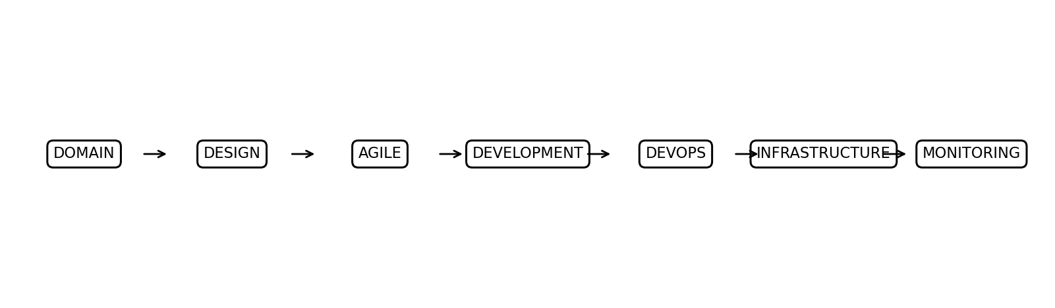
Figure: High-Level Product Engineering Roadmap

16.1 Suggested Sprint Breakdown
Sprint | Focus | Output
Sprint 1 | Authentication + student profile | Login and profile module
Sprint 2 | Attendance | Attendance workflows
Sprint 3 | Examination + results | Academic result module
Sprint 4 | Reports + stabilization | MVP demonstration

16.2 Future Enhancements
- Notifications for academic events.
- Mobile access.
- Analytics dashboards.
- External institutional integrations.
- Advanced reporting and data visualization.

17. SYSTEM ARCHITECTURE AND REPOSITORY STRUCTURE

17.1 Initial System Architecture
The proposed architecture follows a layered approach. Users interact with the presentation layer, which communicates with application services. Business rules are handled in the service layer, while persistent records are maintained in the database layer. Authentication and authorization apply across protected functions.

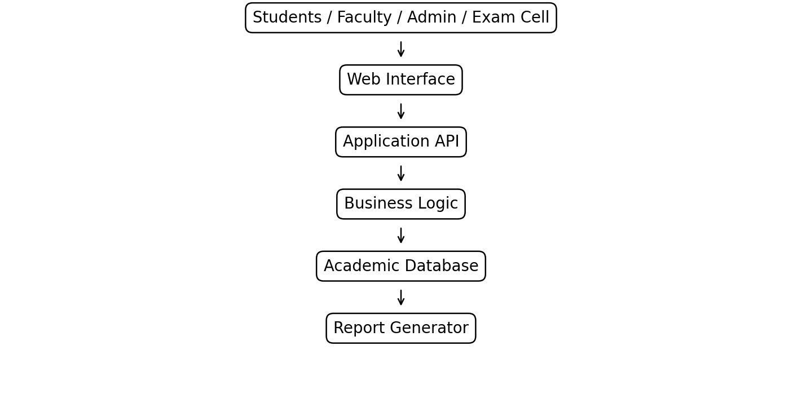
Figure 1: Initial conceptual architecture

17.2 Repository Structure
The training reference provides a standardized repository structure containing application code, tests, documentation, deployment configuration, infrastructure automation, and monitoring configuration.
student-academic-management/
|-- .github/ # CI/CD workflows
|-- app/
| |-- modules/ # Students, Attendance, Exams, Results
| |-- database/ # Schemas and models
| `-- tests/ # Unit and integration tests
|-- docs/ # BRD, FRS, NFRS, design documents
|-- docker/ # Container configuration
|-- deployment/ # Deployment manifests
|-- monitoring/ # Monitoring configuration
`-- README.md # Project setup and usage

18. PROJECT CHARTER, MILESTONES AND CONCLUSION

18.1 Project Charter
Item | Details
Project Name | Enterprise Student Record and Academic Management Platform
Student | Barhate Sanket Maruti
PRN | 2126UDSM2527
Course/Class | DSY 2nd Year - AI & DS
Guide | Karan Gaikwad Sir (IBM)
Institution | Sanjivani University
Department | Artificial Intelligence & Data Science
HOD | K. P. Jadhav Sir
Dean | Kavitha Rani P.
Location | Kopargaon
Project Type | Unit-1 Mini Project
Primary Focus | Design Thinking and Product Planning

18.2 Milestone Plan
Milestone | Deliverable | Status for Unit-1
M1 | Business understanding | Planned/Documented
M2 | Design Thinking | Documented
M3 | Stakeholder + Personas | Documented
M4 | FRS + NFRS | Documented
M5 | Product vision + MVP | Documented
M6 | Roadmap + architecture | Documented
M7 | Repository initialization | Next project activity

18.3 Conclusion
This Unit-1 mini project establishes the product foundation for an Enterprise Student Record and Academic Management Platform. The work starts from business understanding and user needs, then applies Design Thinking, IBM Design Thinking, stakeholder analysis, personas, requirements engineering, product vision, MVP planning, roadmap definition, and initial architecture.
The proposed platform is intended to bring core academic information into a structured digital workflow. The report also separates MVP capabilities from future enhancements so that the project can progress iteratively. The next development stage can use this documentation as the baseline for Agile backlog creation, implementation, testing, and deployment.

18.4 References Used for This Report
- Careertiq Training & Engineering Division, Training & Technical Project Document: Library Management Platform (Unit 1: Product Engineering & Design Thinking), supplied reference document.
- Unit-1 Mini Project: Enterprise Student Record and Academic Management Platform - Design Thinking and Product Planning, supplied project guide.

APPENDIX A - UNIT-1 DELIVERABLE CHECKLIST
The following checklist maps the prescribed Unit-1 deliverables to sections of this report.
Deliverable | Report Section
Business Requirements Document (BRD) | Section 3
Product Vision Document | Section 14
Stakeholder Analysis Report | Section 10
User Persona Report | Section 11
Functional Requirements Specification (FRS) | Section 12
Non-Functional Requirements Specification (NFRS) | Section 13
Design Thinking Report | Sections 4-7
IBM Design Thinking Report | Section 8
IBM Loop Documentation | Section 9
MVP Definition | Section 15
Product Roadmap | Section 16
Initial System Architecture Diagram | Section 17
Project Charter | Section 18
Project Repository Structure | Section 17
Product Discovery Documentation | Throughout report

APPENDIX B - VIVA / PRESENTATION POINTS
- Why was coding not started immediately? Because Unit-1 focuses on understanding the problem and planning the product before implementation.
- What is the main problem? Fragmented/manual academic record handling can cause delays, repeated work, and reporting difficulty.
- What is Design Thinking? A human-centered, iterative approach using Empathize, Define, Ideate, Prototype, and Test.
- What is the IBM Loop? Observe -> Reflect -> Make.
- What is the MVP? The first release containing the core student record, attendance, examination/result, reporting, and access-control capabilities.
- Who are the main stakeholders? Students, faculty, academic administrators, examination cell staff, IT support, and management.
- What comes next? Agile sprint planning and implementation based on the documented requirements and roadmap.

